1. RESOLUTION, NEXT VISIT DATE & TIME as well as NEXT STEPS did not update in OUTCOME HISTORY when UPDATING & PENDING.

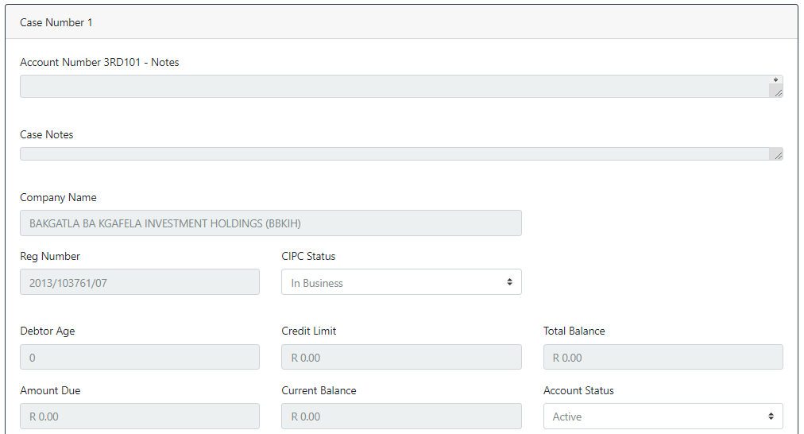

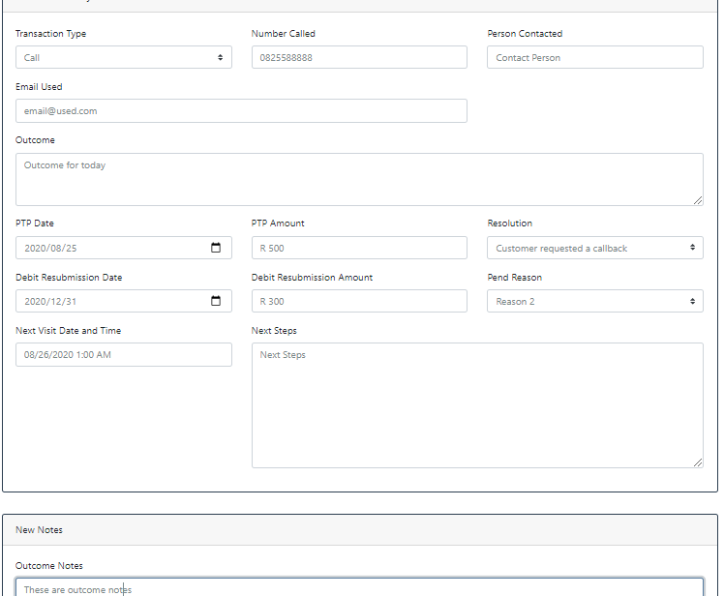

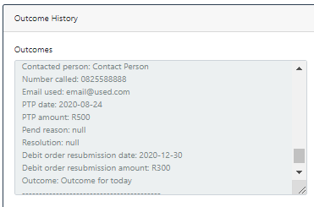

2.Mandatory fields:

* If Transaction Type is EMAIL then EMAIL ADDRESS must be mandatory.
* If Transaction Type is CALL then NUMBER CALLED must be mandatory.

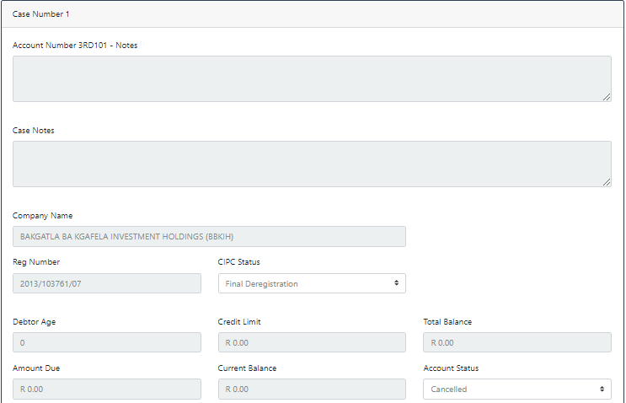

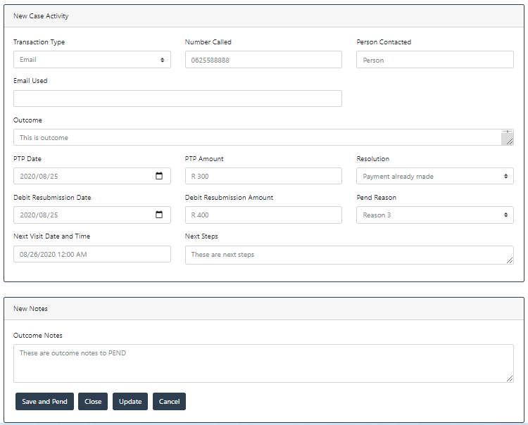

1. Please sort OUTCOMES & OUTCOMES NOTES to show most recent entries first.

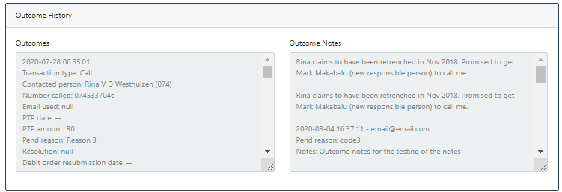

1. Weird.. The CLOSE option updated the RESOLUTION in outcomes for all earlier entries…

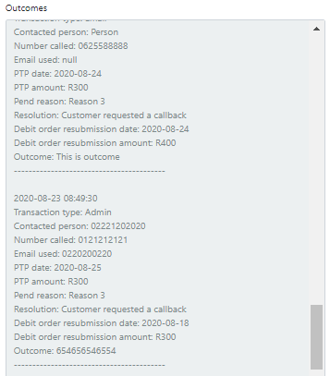

1. Closed this one twice and it keeps ending up as OPEN even though it was Pended before I CLOSED it.

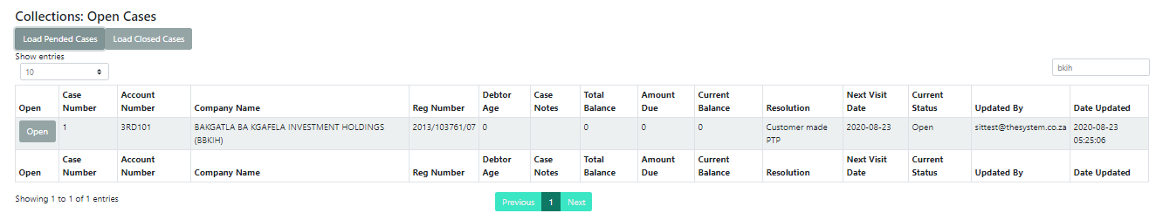

1. Might be easier to read if arranged in 6 columns (instead of reading across):
   1. Primary Contact
   2. Representative
   3. Alternate Representative
   4. Other Contact
   5. Other Email
   6. DNC

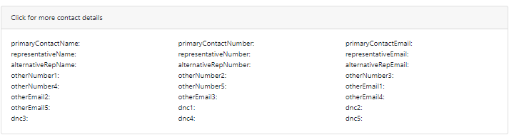

1. Please remember to hyperlink contact numbers so that they initiate the call